TASK 01:

2 BIT COMPARATOR TRUTH TABLE:

|  |  |  |  |  |
| --- | --- | --- | --- | --- |
| A0A1 | B0B1 | L | E | G |
| 00 | 00 | 0 | 1 | 0 |
| 00 | 01 | 1 | 0 | 0 |
| 00 | 10 | 1 | 0 | 0 |
| 00 | 11 | 1 | 0 | 0 |
| 01 | 00 | 0 | 0 | 1 |
| 01 | 01 | 0 | 1 | 0 |
| 01 | 10 | 1 | 0 | 0 |
| 01 | 11 | 1 | 0 | 0 |
| 10 | 00 | 0 | 0 | 1 |
| 10 | 01 | 0 | 0 | 1 |
| 10 | 10 | 0 | 1 | 0 |
| 10 | 11 | 1 | 0 | 0 |
| 11 | 00 | 0 | 0 | 1 |
| 11 | 01 | 0 | 0 | 1 |
| 11 | 10 | 0 | 0 | 1 |
| 11 | 11 | 0 | 1 | 0 |

WHEN LESS:

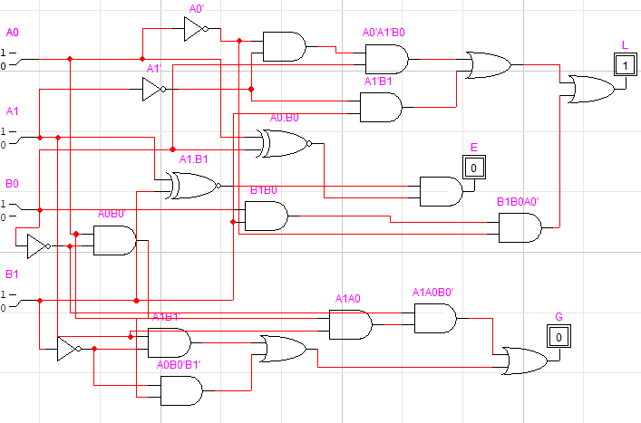

WHEN EQUAL:

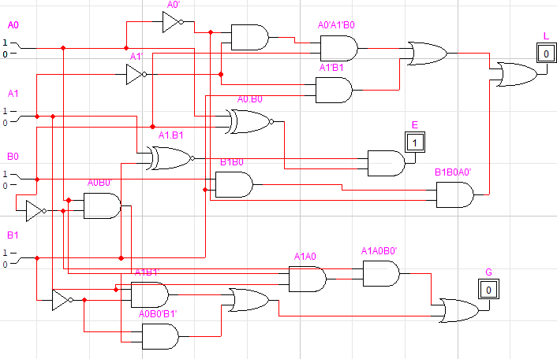

WHEN GREATER:

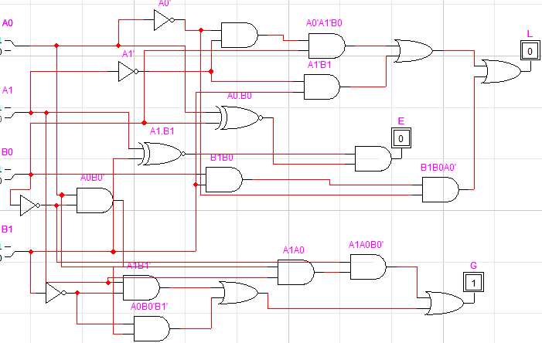

TASK 02:

2 bit adder:

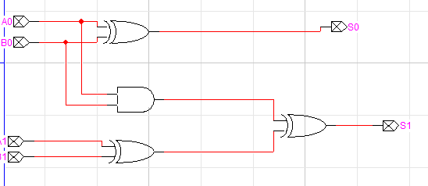

RESULT COMPARATOR:

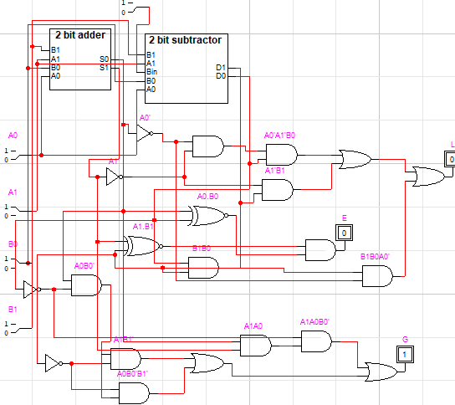

LAB TASK 03:

